LO1 Model User’s Data Requirements Using Conceptual Modeling Techniques

ERD (Entity Relationship Model)
- Entity: anything that can have an independent existence and that can be uniquely identified. An entity is an abstraction of the complexities found in some real-world situations.
- Entities are represented in a database using tables, and each row in a table corresponds to a specific instance or record of that entity. This concept is fundamental to the Entity-Relationship Model, a popular method for designing database schemas.
Here are some key points related to entities in DBMS:
- Entity Type: An entity type is a category or class of objects with common characteristics and attributes. For example, in a database for a library, "Book" and "Author" could be two entity types.
- Attributes: Entities have attributes that describe their properties or characteristics. For instance, a "Book" entity might have attributes like "Title," "Author," "Publication Year," and "ISBN."
- Instances: An instance of an entity type represents a specific occurrence or individual object within that category. Each row in a table corresponds to an instance of the entity. For instance, a particular book with its unique attributes (title, author, etc.) is an instance of the "Book" entity type.
- Entity-Relationship Diagram (ERD): ERDs are used to visualize the structure of a database, including entities and their relationships. They use symbols like rectangles (entities), ovals (attributes), and lines (relationships) to represent these elements.
- Primary Key: In most cases, each entity in a database has a primary key, which is a unique identifier for each instance of the entity. This primary key helps in ensuring the uniqueness of each record and allows for efficient data retrieval.
- Relationships: Entities in a database are often related to each other. These relationships define how different entities are connected or associated. For example, a "Book" entity may be related to an "Author" entity through a "Written By" relationship.
Cardinality and Modality are indicators of the business rules around a relationship.
Cardinality: how many instances of an entity relate to an instance of another entity.
Modality or Ordinality: describes the relationship as either optional or mandatory. (example: one-to-one). the minimum number of times an instance of one entity can be associated with an instance of a related entity
Cardinality can be 1 or Many with the symbol placed on the outside ends of the relationship. Modality can be 1 or zero and the symbol is placed on the inside next to the cardinality symbol.
Cardinality
Modality
Zero or more
One or More
One and only one
Zero or 1
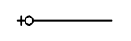
"cardinality" refers to the number of related records or instances in one entity (table) that can be associated with another entity (table) through a relationship. Cardinality is an essential concept in determining how entities are connected and how data is structured in a database. There are different types of cardinalities, including:
One-to-One (1:1) Cardinality:
- In a one-to-one relationship, each record in one entity is associated with exactly one record in another entity, and vice versa.
- For example, in a database for employee records, each employee (record) might be associated with one and only one office location (record).
One-to-Many (1:N) Cardinality:
- In a one-to-many relationship, each record in one entity can be associated with multiple records in another entity, but each record in the second entity is associated with only one record in the first entity.
- For example, in a database for a university, each department (record) can have multiple professors (records), but each professor is associated with only one department.

Many-to-One (N:1) Cardinality:
- This is essentially the reverse of a one-to-many relationship. Each record in one entity is associated with one record in another entity, but each record in the second entity can be associated with multiple records in the first entity.
- For example, in a customer-order database, many orders (records) can be associated with one customer (record), but each order is placed by only one customer.
Many-to-Many (N:N) Cardinality:
- In a many-to-many relationship, multiple records in one entity can be associated with multiple records in another entity.
- For example, in a database for a bookstore, each book (record) can be associated with multiple authors (records), and each author can be associated with multiple books.

One to One
One-to-one implies that there is exactly one row in the Student entity for every row in the Chair entity.

One to Many
One-to-many implies that there can be many courses taught by each instructor

Many to Many
Many-to-many implies an instructor can teach many courses and single course can be taught by many instructors, when assuming multiple offerings for a single course.

2.1 Analyze problems to identify entities and relationships or objects
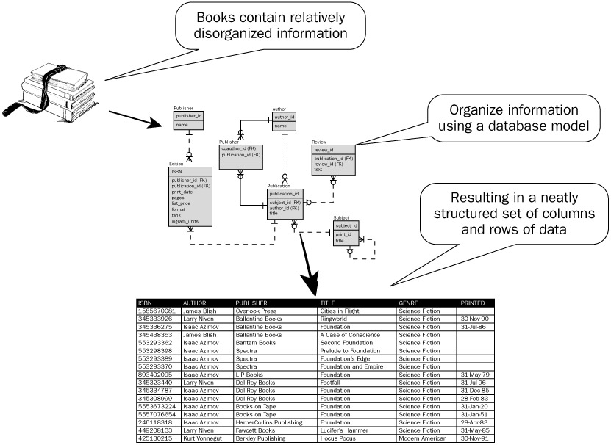

A relationship captures how the entities are related to one another. In its simplest form, a relationship can be thought of as a verb linking two nouns. For example, a company owns a computer, an employee supervises a department, an artist performs a song or a developer writes a computer program
Analyzing problems to identify entities, relationships, or objects is a crucial step in designing a database, software system, or any data-driven solution. This process helps you understand the problem domain and how data and entities are related to one another. Here's a structured approach to help you identify entities and relationships effectively.
Understand the Problem Domain:
Begin by thoroughly understanding the problem or domain for which you are designing a solution. This involves talking to domain experts, reading documentation, and gaining a deep comprehension of the context.
Identify Nouns and Noun Phrases:
Look for nouns and noun phrases in problem descriptions. These often represent potential entities or objects in your system. Examples might include "customer," "product," "order," "employee," etc.
Identify Verbs and Verb Phrases:
Look for verbs and verb phrases that describe actions or interactions within the problem domain. These often represent potential relationships between entities. For example, "places an order," "manages," "is associated with," etc.
Consider Attributes:
For each identified entity, consider what attributes (properties) are associated with it. For example, a "customer" entity might have attributes like "name," "address," and "phone number."
Define Relationships:
Based on the verbs and verb phrases you identified, establish how entities are related to each other. Use terms like "has," "belongs to," "is associated with," and so on to describe these relationships.
Consider Cardinality:
Determine the cardinality of each relationship. Ask questions like, "Can one entity be associated with multiple instances of another entity?" or "Is it a one-to-one, one-to-many, or many-to-many relationship?"
Refine and Validate:
Review your initial analysis with domain experts and stakeholders to validate your understanding. They can provide insights, correct misunderstandings, and help you refine your entity and relationship definitions.
Document Your Findings:
Create documentation that clearly outlines the identified entities, their attributes, and the relationships between them. Diagrams, such as Entity-Relationship Diagrams (ERDs), can be very useful for visualizing these concepts.

Implement and Test:
Once you have a clear understanding of entities and relationships, you can proceed with implementing your solution, whether it's designing a database schema, writing code, or creating other artifacts.
By following this systematic approach to identifying entities and relationships, you can create a solid foundation for designing databases, software systems, or other solutions that accurately reflect the problem domain and meet the needs of your stakeholders.

2 Model Problems with Entity-Relationship Diagrams
The ERD is constructed in an iterative manner. The following approach is taken:
- Determine the Entities. During the analysis phase, customers are asked to list the items that the application or business process addresses. These items evolve into a list of input and output data objects as well as external entities that produce or consume information. Entities are nouns from requirement descriptions.
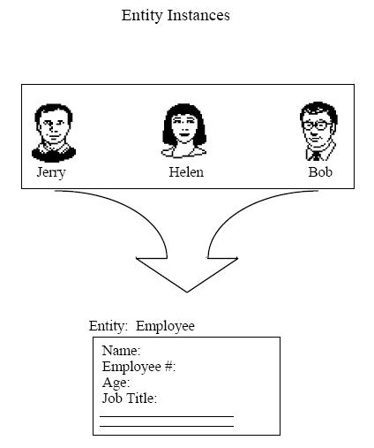
So here we have some instances of an employee entity – jerry, helen and bob. Each of these instances will have their own attributes like name, employee #, age, job title, etc.
- Define the relationships. Relationships are often the verbs found in the requirements description.
  - Taking the objects one at a time, the analyst and customer define whether or not a connection (unnamed at this stage) exists between the data object and other objects.

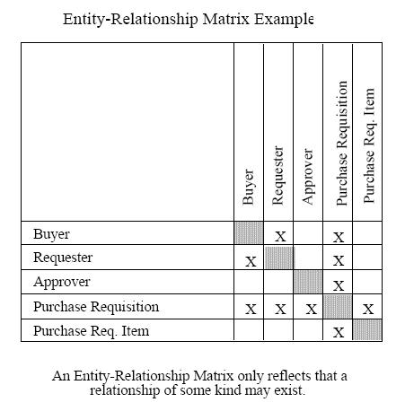

b. Where ever a connection exists, the analyst and the customer create one or more object/relationship pairs.

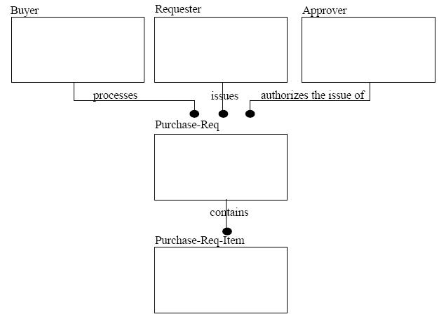

  - For each object/relationship pair, cardinality and modality are explored. What are our relationships? 1 to 1, 1 to many,

Defining the relationship
When determining what type of relationship 1-1, 1-n, or n-n, we look only at the cardinality of both entities.
When reading the relationship, you read the cardinality of one side with the modality of the other.

One to One
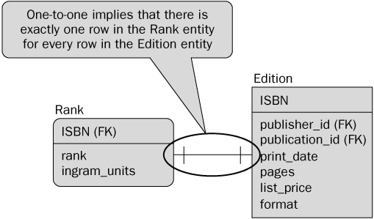

Reading from left to Right – For each rank there is exactly one edition
Reading from right to left – for each Edition there is exactly one rank.

One to Many
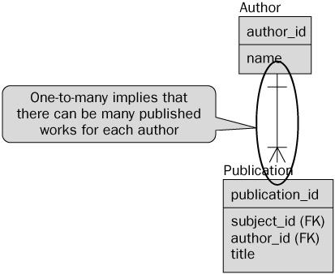
Reading from top-bottom – One author has many publications
Reading from bottom –top – One publication has one author

Many to Many
1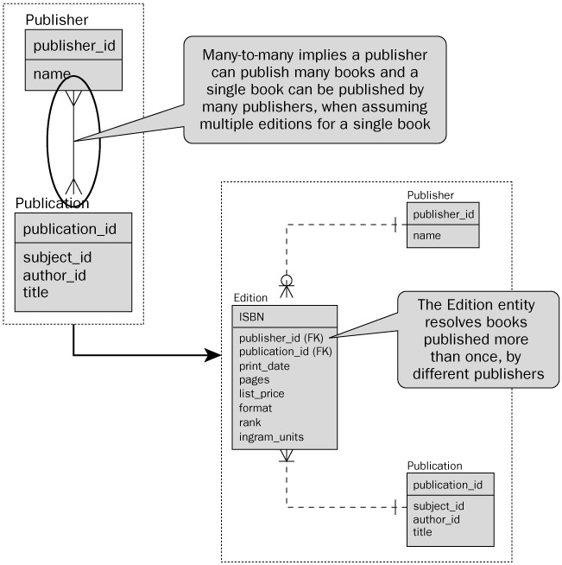
When we have a many to many relationship, it is best practice to break up this relationship to have a joining table between the two tables. This will break the n-n relationship up into two one to many relationships.

Modality – Zero or One
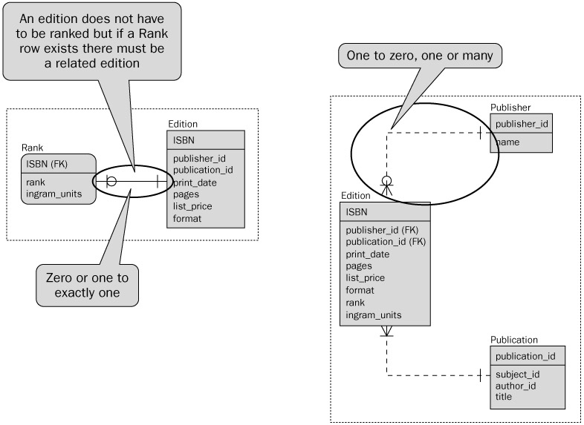

We can also have modality of 0. What this means is that for each record you could have zero or more matching records.

Student: modality = 1 cardinality = 1
Seat: m=1, c=1
Relationship: 1-1

Instructor: m=1,c=1
Course: m=1, c=m
Relationship: 1-m

Student: m=1, c=m
Course: m=1, c=m
Relationship: m-m
Professor: m=1, c=1
Section: m=0, c=m
Relationship: 1-m
- Formalize and review the diagram to ensure it is Normalized.
Now that you have completed the process of defining your entities in the ERDs, the next step is to start rearranging those entities so that when you create your database it is optimized to both search and store efficiently. The process of optimizing the storage of data is called normalization. In order to increase access speed in retrieving information from the database, denormalization, clustering and indexing are used. What makes use of denormalized data??? Data warehousing

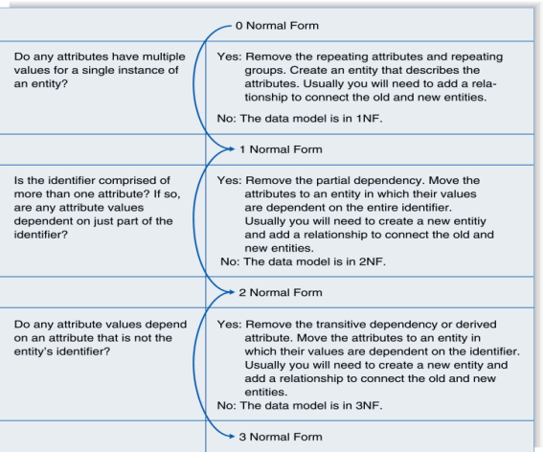
First Normal Form (1NF): NO repeating elements or groups of elements

OrderID | ItemsID1 | ItemsID2 | …
1 | 100 | 101 | …

The ERD is said to be in first normal form if it does not have any repeating attributes. If the ERD has repeating values then those related values that are repeating should be removed and a new Entity should be created out of those values. For example, in the table above, we see that there can be multiple items in a order. Since these values are repeating themselves, they should be removed and placed in a new entity.
In order to solve the problem. we need to remove the repeating columns and create a new table that can still capture this same information.
In effect, we will have one table that tracks order information (order ID, maybe date, customer, payment method, etc.) and we will have a second table that tracks the items that are part of each order

OrderID | ItemID
1 | 100
1 | 101

This creates a much simpler set of entities that are easier to work with. This also helps to reduce the amount of empty space in the database since not all our orders will have the same amount of items, yet because of the previous design, would have to allocate enough space to allow for each order to contain a column for multiple items, even if the space is blank. This also provides the database with more flexibility because an order can have an unlimited number of items.
Second Normal Form (2NF): No partial dependencies on a concatenated key. This is a complex way of saying that if a column isn’t intrinsically related to the entire primary key, then you should break out the primary key into a different table. The ERD is said to be in second normal form if the ERD is in 1NF and that all the attributes are dependent on the primary key. In order to put the model in to 2NF, you will need to move those fields that are dependant on part of the primary key to another table.

OrderID (PK) | ItemID (PK) | OrderDate | …..
1 | 100 | 2013-01-01
1 | 101 | 2013-01-01
The primary key is (OrderID, ItemID)
Consider OrderDate. It is conceptually part of an order. An order always occurs at some time. But is an OrderDate related to an Item? Not really. OrderDate is independent of the item itself. Look at it another way. In the table above the OrderDate will always be the same for a given order regardless of the value of the ItemID column. This means data duplication, which is denormalization.Here is the correction:
OrderID (PK) | OrderDate
1 | 2013-01-01

OrderID(PK) | ItemID(PK) | …
1 | 100
1 | 101

Third Normal Form (3NF): No dependencies on non-key attributes. The ERD is said to be in third normal form if the ERD is in 1NF and 2NF and none of the attributes are dependant on a non-primary key for any of the entities.
2NF covers the case of multicolumn primary keys. Simply, pull out all columns that don’t directly relate to the subject of the row (primary key) and then put them in their own table.
OrderID (PK) | OrderDate | CustomerName | CustomerCity | …
1 | 2013-01-01 | John Smith | Saskatoon
Customer information could be the subject of its own table. Pull out customer name and other customer fields into another table and then put a Customer foreign key into Orders.
OrderID (PK) | OrderDate | CustomerID(FK)
1 | 2013-01-01 | 123

- During the review process you will need to consider the following:
  - Some of the relations generated from the above steps may be dropped due to duplication.
  - Check all joining tables to make sure that when you created the entities you did not break any business rules
  - Review all the relations to make sure they follow the business rules.
- Steps 1-4 are repeated until data modeling is complete

LO 2.3 Compose Relational Schemas from ERDs
Relational model is based on rigorous mathematical principles, and it has a direct correlation to the database design, so the implementation of an E/R model usually involves converting to a relational model first (This also makes it easier to start writing code later)

Steps:

Ensure the diagram is normalized:

For each weak entity (weak entity to strong entity)
(weak entity is an entity that cannot be uniquely identified by its attributes alone)
- Convert to a strong entity by adopting the keys of each entity to which it is related
- The primary key will be a combination of the adopted (foreign keys) and any existing key attributes of the weak entity.

For a many-to-many relationship (N: M)
- Create a new relation with two 1:N relationships.
- The new relation will have a composite key composed of the key fields from the existing parent relations
- If the relationship has attributes, those attributes should be added to the new relation as well.

Review and Consolidate
- Some of the relations generated from the above steps may be dropped due to duplication
- Check all joining tables to make sure that the conversion in step 2 didn't cause any business rules to be broken
- Look at the new relations created to make sure it still follow the business rules

Identify the week entities figure out how to make them stronger. Basically – there needs to be FK’s added so that we can easily link back to a record in another table.

For each entity (Entities to Relations)
- Create a relation with the same name and set of attributes
- If an attribute is composite (made up of more than one possible attribute) you should divide it into multiple pieces. Example: address should be split into city, prov, pc
- The key of the entity will become the key of the relation
- EntityName(attribute list)
- First attribute should be the primary key, and underline it.

For each relationship (Relationships to Relations)
- For a one-to-one relationship (1:1)
  - Take the key from either relation and place it as a foreign key in the other. The choice of which one to use as the foreign key is often a matter of careful consideration of the expected number of entries and the expected number of instances of the relationship. You should put the foreign key into the relation where it will have the fewest null values.
- For a one-to-many relationship (1:N)
  - Take the key from the one relation (parent) and place it as a foreign key in the many relation (child).
Note: Reviewing the above, if you see that the same named attribute appears in a few relations, you may rename attributes to avoid confusion. For Example: change name attributes to be instructorName, and studentName.
For all relationships – list referential integrity constraints for foreign keys and unique attributes
Add to your relational model the FK in form of attribute name(FK)
Write the constraint in the form:
Entity (foreign key (FK)) references parentEntity(primarykey)

Final Schema
- List relation names and attributes in the form
  - RelationName(attribute1, attribute2, attribute3(fk), …)
  - List all referential integrity constraints for foreign keys and unique attributes

Example 1:
Let’s say that one of the analysts hands you this diagram and tells you it’s not quite finished but that you need to convert it to the relational model so that the DBA can create the database. You can see that the analyst was thinking that they needed to add a Section and a method of tracking the grade achieved.

DASHED LINE: Usually it means the relationship is non-identifying/weak. In relational terms, the foreign key is not part of the primary key of the referencing table.

dotted line it means that the relationship is a non-identifying/associative (i.e: the foreign key in entity1 is not part of the primary key from entity2 - or similarly that entity1 is not identified by its entity2)

- Normalize
  - Make weak entities strong
    - Faculty needs a fk to Department
    - Student needs an fk to faculty
    - Student needs an fk to Major
    - Major needs an fk to Department
  - Many-to-Many relationships
    - Add a grade table and a section table
      - Grade: gradeAchieved
      - Section: sectionNum, credit, room, time
  - Review and consolidate
    - Section needs pk/fk to faculty and to course
    - Grade needs a pk/fk to Section and Student
    - NOTE: you could decide that Grade actually needs it’s own surrogate key because maybe a student takes the same course multiple times and has different grades and you want to store a history of all those grades.

- For each entity:
EntityName(attribute list)
First attribute should be the primary key, and underline it.
      - Faculty (facultyID, firstName, lastName, position, deptNumber(fk))
      - Department (deptNumber, name, streetNo, city, prov, postalCode)
      - Course (courseNumber, name)
      - Student (studentID, firstName, lastName, streetNo, city, prov, postalCode, majorID(fk), facultyID(fk))
      - Major (majorID, name, description, deptNumber(fk))
      - Section(facultyID(fk), courseNumber(fk), sectionNum, credit, room, time)
      - Grade(studentID(fk), facultyID (fk), courseNumber(fk), gradeAchieved)

2. For each relationship:
Write the constraint in the form:
Entity (foreign key (FK)) references parentEntity(primarykey)
      - "is member of" 1:N relationship
        - Faculty(facultyID, firstName, lastName, position, deptNumber(fk))
        - Constraint:
      - Faculty (deptNumber(fk)) references Department(deptNumber)
      - "advise" 1:N relationship
        - Student(studentID, firstName, lastName, streetNo, city, prov, pCode, facultyID(fk))
        - Constraint:
      - Student(facultyID(fk)) references Faculty(facultyID)
      - "chooses" 1:N relationship
        - Student(studentID, firstName, lastName, streetNo, city, prov, pCode, facultyID(fk), majorID(fk))
        - Constraint:
      - Student(majorID(fk)) references Major(majorID)
      - "offers" 1:N relationship
        - Major(majorID, name, description, deptNumber(fk))
        - Constraint:
      - Major(deptNumber(fk)) references Department(deptNumber)
      - "teach" N:M relationship
        - Section(facultyID(fk), courseNumber(fk), sectionNum, credit, room, time)
    - Constraint:
      - Section (facultyID(fk)) references Faculty(facultyID)
      - Section (courseNumber(fk)) references Course(courseNumber)
      - "enrolls" N:M relationship
        - Grade(studentID(fk), facultyID (fk), courseNumber(fk), gradeAchieved)
        - Constraints:
      - Grade(studentID(fk)) references Student(studentID)
      - Grade(facultyID(fk), courseNumber(fk)) references Section(facultyID, courseNumber)

- Final Schema:
      - Faculty (facultyID, firstName, lastName, position, deptNumber(fk))
      - Constraint:
        - Faculty (deptNumber(fk)) references Department(deptNumber)
      - Department (deptNumber, name, streetNo, city, prov, postalCode)
      - Section (facultyID (fk), courseNumber(fk), sectionNum, credit, room, time)
      - Constraint:
        - Section (facultyID(fk)) references Faculty(facultyID)
        - Section (courseNumber(fk)) references Course(courseNumber)
      - Student(studentID, firstName, lastName, streetNo, city, prov, pCode, facultyID(fk), majorID(fk))
      - Constraint:
        - Student(facultyID(fk)) references Faculty(facultyID)
      - Major (marjorID, deptNumber(fk),name, description)
      - Constraint:
        - Major(deptNumber(fk)) references Department(deptNumber
      - Course (courseNumber, name )
  - Grade (studentID (fk), facultyID(fk), courseNumber(fk), sectionNumber(fk), gradeAcheived)
    - Constraints:
      - Grade(studentID(fk)) references Student(studentID)
      - Grade (courseNumber,sectionNum(fk)) references Section(courseNumber,sectionNum)

Example 2:
The following diagram represents a simplified credit card environment. There are two types of accounts: debit cards and credit cards. Credit card accounts accumulate charges with merchants. Each charge is identified by the date and amount of the charge. Transform the ER diagram into a set of relations. Be sure to identify the primary (and foreign) keys in the resulting relations.

Example 3:
Converting Library example to relational schema

Convert Relational Schema into Table information (to be used to later create a table).
      - Faculty (facultyID, firstName, lastName, position, deptNumber(fk))
      - Constraint:
        - Faculty (deptNumber(fk)) references Department(deptNumber)
      - Department (deptNumber, name, streetNo, city, prov, postalCode)
      - Section (facultyID (fk), courseNumber(fk), sectionNum, credit, room, time)
      - Constraint:
        - Section (facultyID(fk)) references Faculty(facultyID)
        - Section (courseNumber(fk)) references Course(courseNumber)
      - Student(studentID, firstName, lastName, streetNo, city, prov, pCode, facultyID(fk), majorID(fk))
      - Constraint:
        - Student(facultyID(fk)) references Faculty(facultyID)
      - Major (marjorID, deptNumber(fk),name, description)
      - Constraint:
        - Major(deptNumber(fk)) references Department(deptNumber)
      - Course (courseNumber, name )
  - Grade (studentID (fk), facultyID(fk), courseNumber(fk), sectionNumber(fk), gradeAcheived)
    - Constraints:
      - Grade(studentID(fk)) references Student(studentID)
      - Grade (courseNumber,sectionNum(fk)) references Section(courseNumber,sectionNum)

Table: Faculty
Column | Datatype | Null? | Check | Default | Key | References
facultyID | CHAR(17) | No |  |  | Primary
firstName | VARCHAR2(30)
lastName | VARCHAR2(30)
position | VARCHAR2(6)
deptNumber | Number(8) | No |  |  | Foreign | Department(deptNumber)

